Chapter 2: Mixtures

2.1 Mixtures are a combination of two or more substances

Student worksheet answers (pages 30–31)

Mixtures

Part 1 – In the mix

1 This is a list of substances that make up a typical cup of tea: tea bag, milk, water, sugar, and a cup. Label the diagram below by stating in the boxes whether these substances are pure or a mixture.

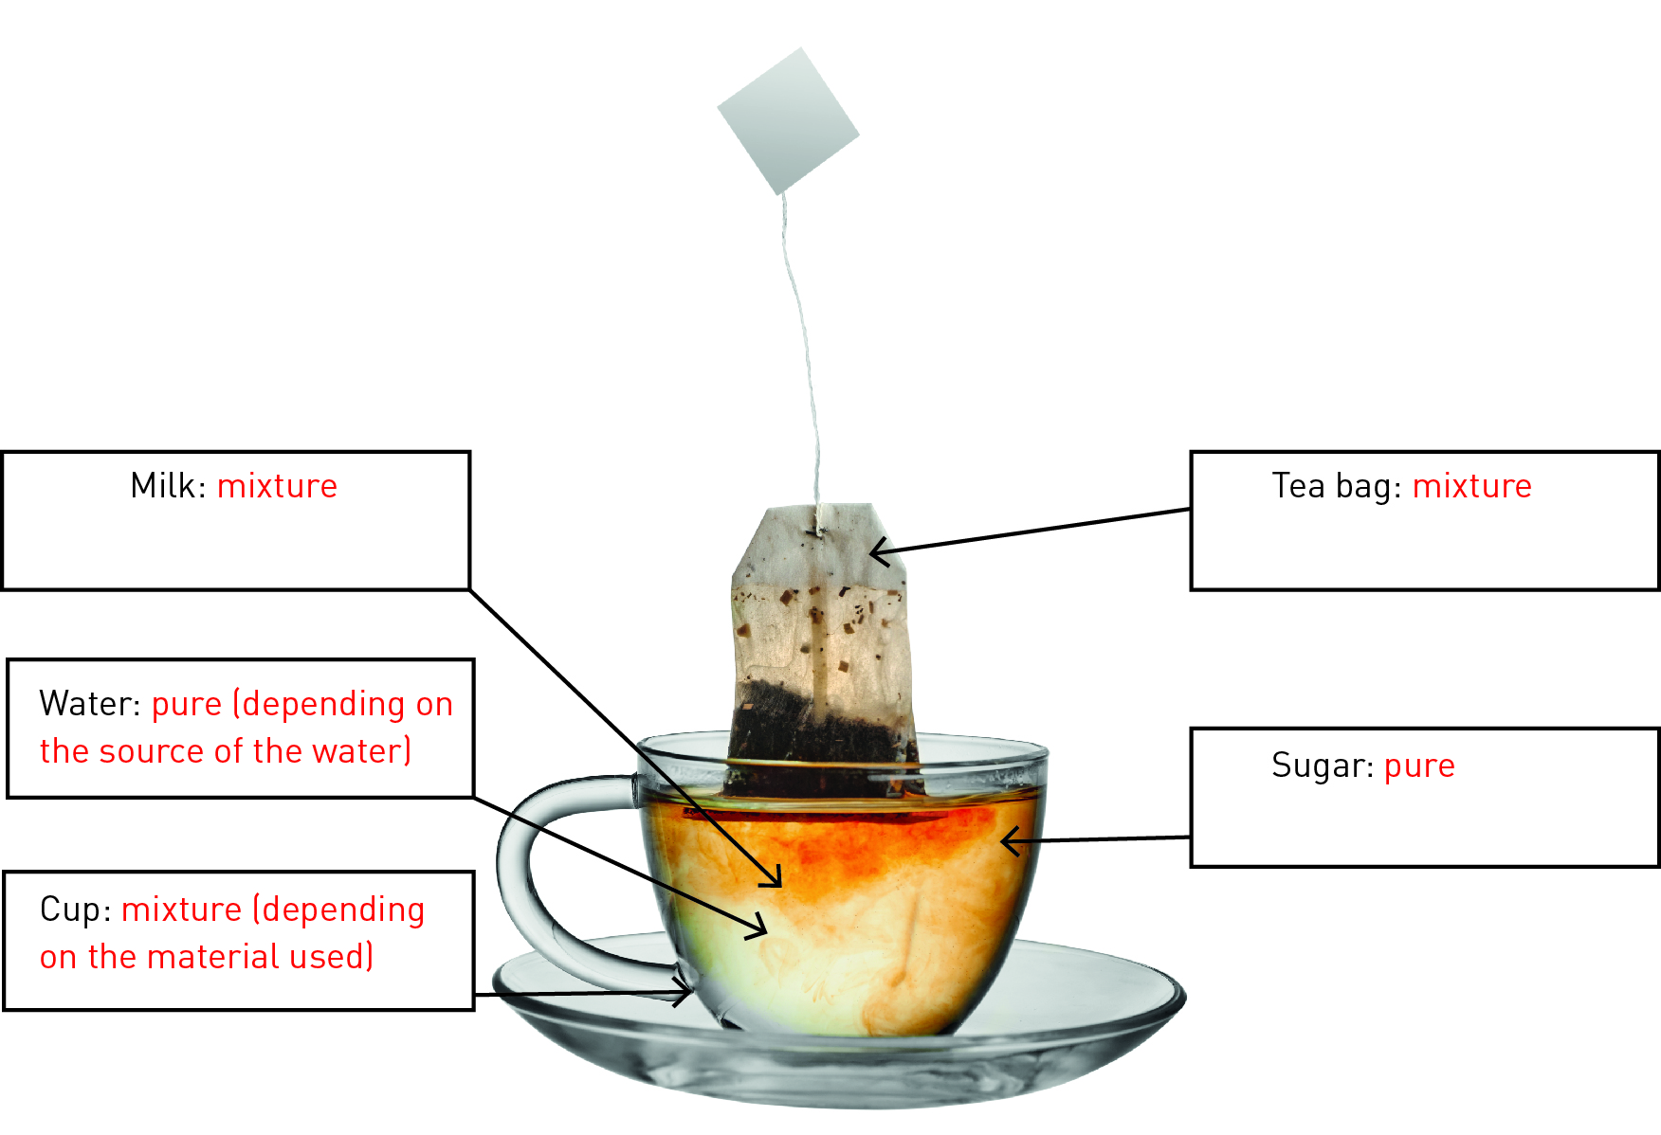

2 Is river water a pure substance? Why or why not?

River water is not a pure substance. It is a mixture because it contains water plus other components, such as dirt, dissolved minerals and gases, salt, living organisms etc.

Part 2 – The suspense is building

3 The diagram below shows how sea waves transport eroded materials and deposit these materials onto the beach.

a What type of substances would be in solution in seawater?

The main substance would be salt, but dissolved gases would also be in solution in seawater.

b What substances would be in suspension in seawater?

The main substance in suspension in seawater would be sand, although other substances, such as microscopic living organisms, human pollutants etc., would also be in suspension.

c Think about a beach you have visited. What types of materials are deposited on the beach?

Student responses will vary, but most should mention sand, seaweed, sticks, rubbish and shells as materials deposited on a beach.

d Imagine you took a jar full of seawater from the shore (the swash and backwash area). Draw a labelled diagram to show what the jar might look like before and then after the solid particles settled. Use the terms ‘suspension’ and ‘sediment’ in your labels.

Before

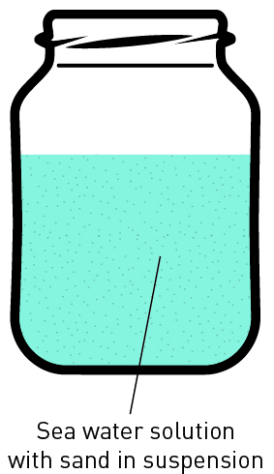

After

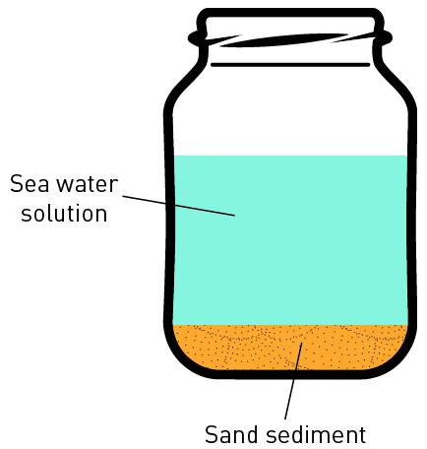

Part 3 – Let’s stick together

4 Colloids and suspensions have similarities and differences. Some drinks (e.g. chocolate-flavoured milk) are a mixture of a colloid and a suspension.

a To make sure you get the full chocolate flavour, what do you have to do to chocolate-flavoured milk before you open the container to drink it?

The chocolate forms a sediment, so you need to shake the container to put the chocolate back into suspension.

b Do you need to do the same to a container of plain milk before opening it?

Plain milk is a colloid so does not need shaking before opening.

c The chocolate would be a sediment before you shake the container, but a suspension after you shake the container. However, the milk would be a colloid regardless of whether it was shaken or not. This is because milk is an emulsion of different liquids.

EXTEND YOUR UNDERSTANDING

5 Extend your understanding by using the Internet to research the science behind this old nursery rhyme:

*Little Miss Muffet*

*Sat on a tuffet,*

*Eating some curds and whey.*

*Along came a spider*

*Who sat down beside her,*

*And frightened Miss Muffet away.*

Little Miss Muffet was a small girl whose name was Patience Muffet. Her stepfather, Dr Muffet (1553–1604), was a famous entomologist who wrote the first scientific catalogue of British insects.

a What are curds and whey?

Curds are the milk solids or fats, and the whey is the liquid or watery part of the milk.

b How can the milk emulsion be separated into curds and whey?

Milk is a colloid but can be separated by adding an acid, such as vinegar or lemon juice, to it. Making the milk more acidic causes the protein (casein) particles to come out of solution as solid chunks of curds floating in the liquid whey.

2.2 A solution is a solute dissolved in a solvent

Student worksheet answers (pages 32–33)

Is there a solution?

1 Each of the foods and drinks listed below has been formed as a result of solubility. Name the main solute and the solvent in each.

|  |  |  |
| --- | --- | --- |
| Substance | Solute | Solvent |
| Hot chocolate | Chocolate | Milk |
| Black coffee | Coffee | Water |
| Instant gravy | Gravy powder | Water |
| Jelly | Jelly crystals | Water |
| Soda (carbonated) water | Carbon dioxide | Water |

2 Solutions are generally see-through or transparent. Which of the foods or drinks listed above could be classified as solutions?

Jelly and soda water could both be considered solutions as the solute dissolves completely into the solvent.

3 Look at the bottle and the jug below. Both have been filled with a blue solution, but one is more concentrated than the other.

a In the space provided, draw a diagram to represent the solute particles in both containers.

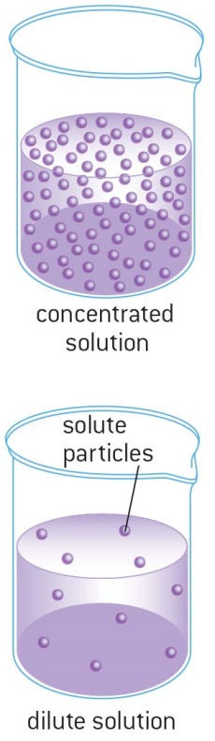

b Which container had the lowest concentration of the solute?

The jug has the lowest concentration of the solute.

c What is the simplest way to make both the solutions in the containers more dilute?

Adding more solvent would dilute both solutions.

4 Fish are a very common pet for children to have because they can be kept in a bedroom and are easy to look after…as long as you understand the importance of gases dissolved in liquids.

a Why is it important to have green plants or a bubbling filter in fish tanks?

The green plants or bubbling filters add dissolved oxygen to the water, which is essential for fish. Some students may refer to photosynthesis in their response.

b Could a fish survive in a tank full of pure water but nothing else?

Fish could not survive in pure water because it would lack dissolved oxygen. Dissolved oxygen in the water would create a mixture.

EXTEND YOUR UNDERSTANDING

5 Water is the most common solvent but there are also other useful solvents. Research at home or on the Internet which solutes will dissolve in the solvents listed below.

|  |  |
| --- | --- |
| Solvent | Solutes that will dissolve in this solvent |
| Methylated spirits | Methylated spirits will dissolve some paints, inks (such as those found in marker pens) and grease |
| Kerosene | Kerosene will dissolve some glues and waxes |
| Turpentine | Oil paints are solutes that will dissolve in turpentine |
| Acetone | Nail polish is soluble in acetone, which is why many nail polish removers contain acetone |

2.3 Mixtures can be separated according to their properties

Student worksheet answers (pages 34–35)

Separate properties

1 Examine each of the images below. Name and explain the most effective method to separate the components of each of the mixtures according to their properties.

a Simple separation should be used. Fingers could easily separate the different types of lollies.

b Magnetic separation would be used to separate the different varieties of metal, particularly magnetic and non-magnetic.

c Decanting would allow the water to be poured off in order to separate it from the solid sediment.

2 Your science teacher brings a large bucket to class. Inside the bucket is a mixture of the following: water, sand, iron nails and grass clippings floating on top. Your task is to separate the four components using four different methods of separation.

Draw a simple diagram and write a brief description of the steps you would take in the flow chart below. Consider the order of the methods.

Bucket containing water, sand, iron nails and grass clippings.

↓

The grass clippings would be floating on top, and so could be removed by scooping them up with a spoon.

The diagram should show a bucket with a spoon scooping out grass clippings.

↓

The iron nails could be separated next by magnetic separation, using a magnet dipped into the bucket.

The diagram should show a magnet being lowered into the bucket and nails attached to the magnet.

↓

The water can be separated by decanting the liquid into another container.

The diagram should show water being tipped out of the bucket.

↓

The sand should remain as a sediment in the bottom of the bucket.

The diagram should show a bucket with sand in the bottom.

EXTEND YOUR UNDERSTANDING

3 Extend your understanding by researching some of the methods that were used to clean up the Deepwater Horizon oil spill in the Gulf of Mexico in 2010.

Student responses will vary but could include reference to booms, which are floating physical barriers that slow the spread of the oil, and skimmers, which are used to remove oil from the sea surface before it reaches sensitive areas along a coastline.

2.4 Mixtures can be separated according to their size and mass

Student worksheet answers (pages 36–37)

Separating mixtures

Part 1 – Separation by filtration

1 Below are two different filters, a HEPA filter and a colander.

a Describe at least two features both filters have in common.

Both these filters separate large particles from smaller particles. Both have a series of holes that let smaller particles pass through.

b Describe how these two filters are different.

The colander filters particles from liquids, whereas the HEPA filter filters particles from the air. The HEPA filter filters fine particles, whereas the colander filters much larger particles only.

2 Label the diagram using the following words: funnel, filter paper, residue, filtrate

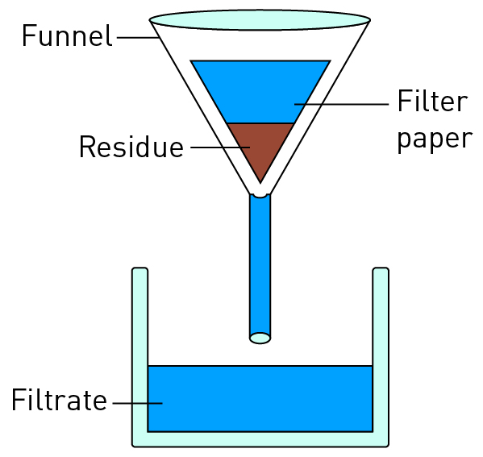

a Name three mixtures that could be separated using this method

Student responses will vary, but could include tea leaves from water, orange pulp from juice and food particles from a consommé.

b Identify at least five different filters that are present in your home.

Student responses will vary but could include: heater, air conditioner, vacuum cleaner, sieve, sink strainer.

Part 2 – A spin on separation

3 A test tube of blood is spun in a centrifuge to separate it into its components.

a How is the blood separated in the centrifuge?

The red blood cells collect at the bottom of the tube and the plasma and platelets collect at the top.

b Why is the blood separated in the centrifuge in this way?

The red blood cells are heaviest and therefore sink to the bottom when spun in a centrifuge. The plasma and platelets are lighter, so they float to the top.

4 If you have ever been camping you may have made ‘billy tea’. The tea leaves and water are put into the billy, which is placed on the fire. Once the water has boiled, the billy is picked up and swung around in a large circle.

a Why do you think the billy is swung around in a large circle?

Swinging the billy in a large circle causes the tea leaves to sink to the bottom of the billy because of centrifugal forces.

b What method of separation would be used to pour the drinkable tea out of the billy but leaving the tea leaves behind?

The drinkable tea can be decanted from the tea leaves at the bottom of the billy.

EXTEND YOUR UNDERSTANDING

5 Find out how centrifuges are used in the production of dairy products such as cream.

A device called a separator is used in the production of dairy products, most commonly to separate the skim milk from the cream. A separator is a centrifuge that spins the raw milk, with the heavier skim milk pulled towards the walls of the separator while the lighter cream collects in the middle.

2.5 The boiling point of liquids can be used to separate mixtures

Student worksheet answers (pages 38–39)

Going off the boil

1 Imagine you made a cup of tea at home for a friend and accidentally put in sugar. Instead of making a new cup of tea, you decided to use your knowledge of science to separate this mixture. So you decide to pour the cup of tea into a saucepan and put it on the stove.

a What method of separation are you using?

Crystallisation is the separation method used to separate the tea from the sugar.

b Is this method an effective way of removing the sugar from the cup of tea?

This method would remove the sugar, but unless distillation occurs the liquid tea would evaporate.

c What would happen to the liquid tea?

The liquid tea would evaporate.

3 Would it have been better to make another cup of tea for your friend?

Yes, it would have been better to make another cup of tea.

2 The table below shows the boiling points of common liquids.

a Use the data to create a column graph ranging from the lowest to the highest boiling point in the space provided.

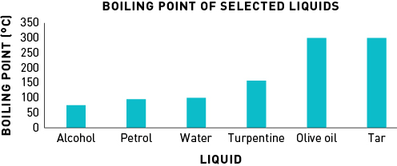

b What would be some safety concerns if you tried to separate a mixture of all of these commons liquids at home?

Student responses will vary but could include the high temperature, flammability and toxicity of some substances.

3 The equipment used for distillation in the science laboratory involves a number of different apparatus. On the diagram below, label the equipment.

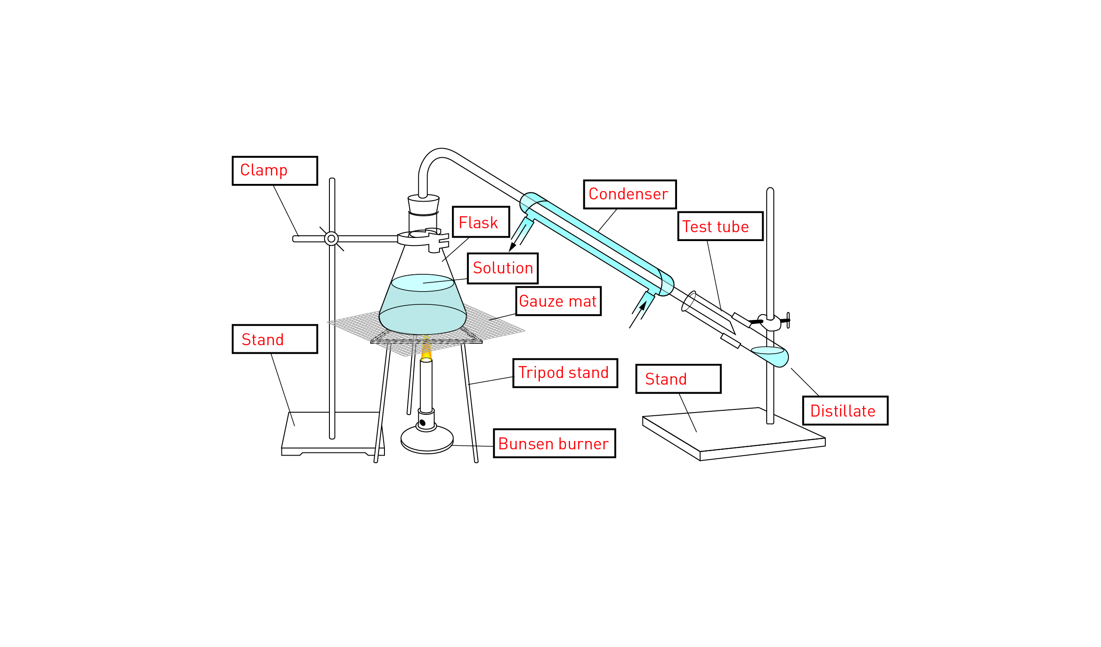

EXTEND YOUR UNDERSTANDING

4 Extend your understanding by examining the diagram below, which shows the various products that can be separated from crude oil in the process of fractional distillation. Research one use of the products extracted from crude oil.

a Gas

Heating and cooking

b Petrol

Fuel for vehicles such as cars and motorbikes

c Kerosene

Fuel for jet planes

d Diesel oil

Fuel for trucks and non-electric trains

e Fuel oil

Fuel for power stations and ships

2.6 Solubility can be used to separate mixtures

Student worksheet answers (pages 40–41)

A mixture to dye for

1 What is the Rf value of:

a purple?

Purple travelled 2 cm, the solvent travelled 9 cm; thus, Rf = 2 ÷ 9 = 0.22

b orange?

Orange travelled 6 cm, the solvent travelled 9 cm; thus, Rf = 6 ÷ 9 = 0.67

c blue?

Blue travelled 8 cm, the solvent travelled 9 cm; thus, Rf = 8 ÷ 9 = 0.89

EXTEND YOUR UNDERSTANDING

2 Extend your understanding by calculating the Rf value of the colours in Experiment 2.6 ‘Who wrote the nasty note’, on page 182 of the textbook.

Student responses will vary depending on the results of this experiment.

2.7 Science as a human endeavour: Waste water is a mixture that can be separated

Student worksheet answers (pages 42–43)

What a waste

1 Use the information from pages 42-43 to answer the questions surrounding the diagram below.

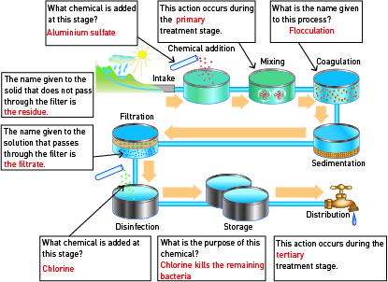

2 The diagram below shows the primary stage in further detail.

a What type of mixture is the raw sewage inflow?

The raw sewage is a suspension, with some substances in solution.

b What separation process has caused the solid sewage sludge to form?

Sedimentation has caused the sludge to form.

c How has aluminium sulfate been used in this process?

Aluminium sulfate is a flocculent, which causes the suspended particles to clump together.

EXTEND YOUR UNDERSTANDING

3 Try to work out the answer to the following question:

In the lake pictured, there is an algal bloom. Every day, the algal bloom doubles in size. If it takes 34 days for the algal bloom to cover the entire lake, how long did it take for the algal bloom to cover half the lake?

The algae would take 33 days to cover half the lake. If they double each day, and half the lake is covered, it would take one more day to cover the entire lake.